Nome: Jose Paulo Jorge dos Santos

Data: 15/ 01 / 2018

1 - B

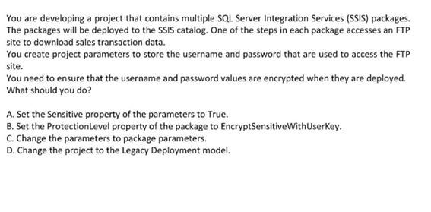

2- A

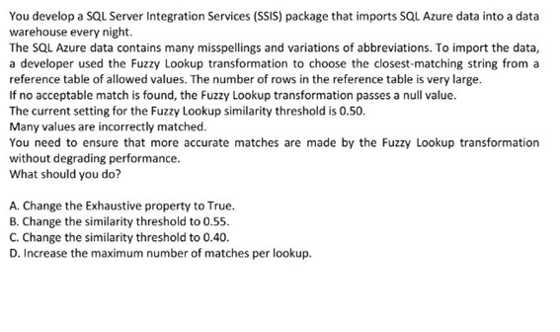

3

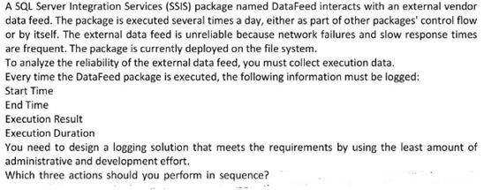

|  |  |
| --- | --- |
| Add **OnError** and **OnWarnin**g event handlers. | **A** |
| Query the **catalog.executable_statistics** view | **B** |
| Query the **ExecutionLog** table. | **C** |
| Deploy the project that contains the package to the SSIS catalog and execute the package on the server. | **D** |
| Deploy the package to the msdb database | **E** |
| Add an Execute SQL task to the event handlers. | **F** |
| Query the **catalog.execution_data_statistics** view. | **G** |
| Create a new project and add the package to the project. | **H** |

4 - E

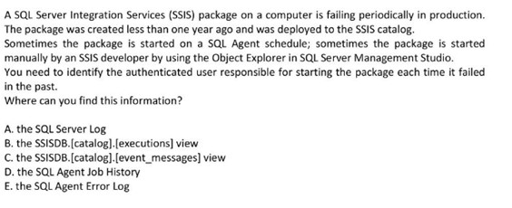

5 C

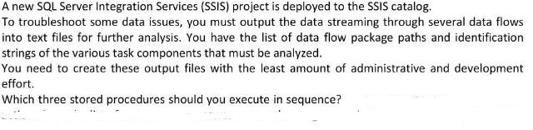

|  |  |
| --- | --- |
| **catalog.create_folder** | A |
| **catalog.create_execution_dump** | B |
| **catalog.add_data_tap** | C |
| **catalog.configure_catalog** | D |
| **catalog.add_data_tap_by_quid** | E |
| **catalog.create_execution** | F |
| **catalog.start_execution** | G |

6 – C

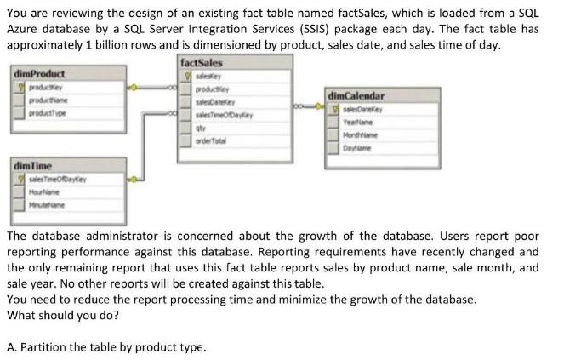

7 - K

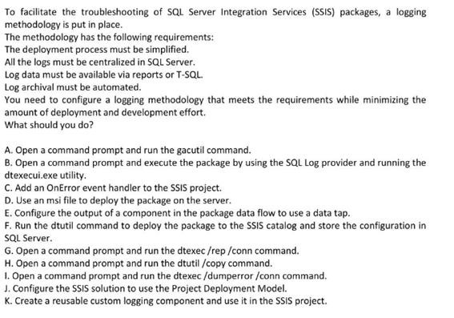

8 – C

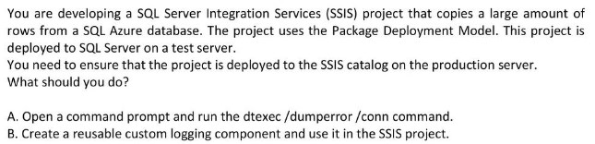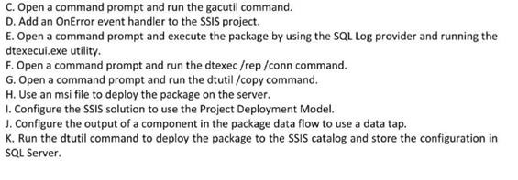

9 - B

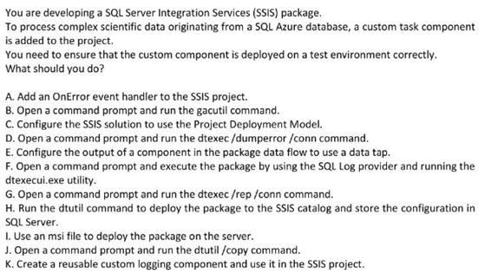

10 - Fuzzy LookUp

